Knights of Columbus
Holy Family Council 11811
General Membership Meeting – July 28, 2026

Opening Prayer - The Lord’s Prayer…Jeff Bogio DGK

Pledge of Allegiance

Recognition of Dignitaries
Roll Call of Officers: Tim May
Approval of Minutes from Previous Meeting: Approved
Members in Attendance: 8
Meeting Duration: 35 minutes

Chaplain | Fr. Bob LaCroix | E | Grand Knight | Keith Siopes | E
Deputy Grand Knight | Jeff Boggio | P | Chancellor | Mike Dompierre | E
District Deputy | Paul Kueber | E | Recorder | Tim May | P
Financial Secretary | Rob Spallone | E | Treasurer | David Meier | P
Lector | Vacant |  | Advocate | Gary Rose | P
Warden | Kevin Daly | E | Inside Guard | Tom Busard  Mike Drapeau | E
Outside Guard | Chris Gier | P | Trustee 1yr | Tom Herc | E
Trustee 2yr | Mbella Likine | E | Trustee 3yr | Dave Stulock | P

Grand Knight Report (Keith Siopes) –Given by DGK
- COR EFF Due. Please complete & submit.
- 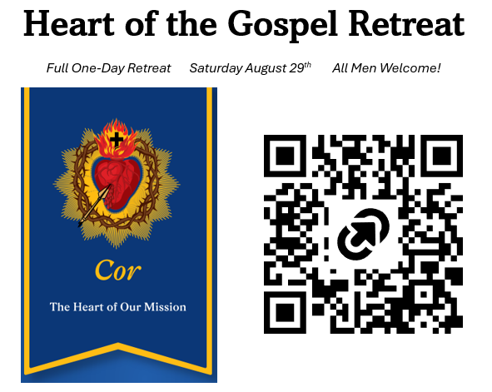
- 2026 KofC Living Rosary, Sunday Sept, 13th, at 2:00pm, State Capitol
- DD112 Installation of Officer’s at St. Fabian Date TBD (a Sunday in August), need headcount

- The Signup Genius link is now active for our 2026 Ren Fest Volunteer weekend 9/5-7/2026. Please send to all folks in your group and sign up early to get the shifts you want. We have a new volunteer check-in area to avoid the mud and give us a bit more space for check-in, see the map on the sign-up.
  - Parking passes require your license plate and cell phone number on the signup, please do not put generic info in either space. Missing info means you will not receive a parking pass email in August and hence will need to walk back to your car in the morning to avoid a parking ticket and potential tow truck bill.
  - https://tinyurl.com/RenFair26
- 2026 Gala A Mother’s Love, Heart of Christ Clinic – Thurs Sep 17, 2025 St. John’s Resort, $150/ticket, $1500/table
- HF Christmas event at Manor of Novi – Saturday 12/12/26 10:00am-12:00pm
Deputy Grand Knight Report (Jeff Boggio)
- No formal report
Financial Secretary’s Report (Rob Spallone) Given by Treasurer
- General Acct: $ 1,946.67 Charity Poker Acct: $ 8,206.90 Total: $ 10,153.37
Treasurer’s Report (Dave Meier)
- Treasurer balances with FS
Membership Director (Jeff Boggio)
- Recruit at least 1 e-member in July.
Newsletter Editor (Kevin Daly)
- No report
Chancellor’s Report (Mike Dompierre)
- No report
Program Director’s Report (Tom Herc)
Faith Director (Justin Dimase)

Community Director (Steve Ernster)
- Sleep in Heavenly Peace – August 30th, need volunteers
- Soup Troop – Cook Friday 8/5, Transport & Serve Saturday 8/8. Kevin Daly is coordinating.
Family Director (Rob Spallone)
- No report
Life Director (Gary Rose)
- Discussed the concern regards in global population shrinkage and it’s correlation to reduced church families.
- Spoke about the current political movement toward the left and the impact on US family growth
- Proposed the council look into supporting the Heritage Foundation, which is dedicated to the preservation of Life, Community, Family and Patriotism
Fund Raising Committee (Tom O’Connor)
- Charity poker – Thursday Oct 1 – Sunday Oct 4th.
- Sign-up will begin at the August general membership meeting

Trustees (Mbella Likine. Dave Stulock, Tom Herc)
- Family of the Month _Tabled until August mtg
- Knight of the Month_Tabled until August mtg

4th Degree Update (Dave Stulock)
- 4th degree Installation of Officers in schedule for August 15, 2026
District Deputy Report (Paul Kueber)

Insurance Agent (Rudy Fiscelli Jr.) Absent
- Contact Rudy at rudy.fiscelli@kofc.org

Old Business
- Financial Transactional efficiency

New Business
- Discussion on the focus to transition the Fund Raising Chair next year when Tom O’Connor steps back
- Benefit on the Bay dinner for Capuchin soup kitchen $250/person
- KofC Tiger Game…August 29th vs Dodgers, Tickets: $50 mezzanine $65 box seats
- KofC Lion’s Game…November 22nd vs Tampa Bay $300/ticket
Closing prayer and prayer list
- Prayer list will be sent with minutes

Next Meetings:
- Officers meeting: August 11th @ 7:00pm
- General Council: August 25th Dinner 6:30pm Meeting 7:00pm

Dinner Volunteer August 25th: Tim May

